Building At Borivali.

Project Details
- Project Name: __________________
- Location: Borivali.
- Plot Area: __________________
- Built-up Area: __________________
- Project Type: Residential building refurbishment
- Design Firm: Wall Voids Architects
- Status: __________________
- Completion Year: __________________

1. Project Overview
An existing residential development was refurbished to create a stronger contemporary identity and an improved arrival experience. The intervention focused on the entrance, podium façade, commercial frontage, common lobby and lift lobby. New architectural finishes, lighting, landscaping and signage were introduced while retaining the original building structure.

2. Building Features
- Residential towers with podium parking and commercial units
- Redesigned entrance gateway and vehicular access
- Vertical green wall with integrated project signage
- Contemporary podium screening with vertical fins
- Enhanced commercial frontage and pedestrian approach
- Premium common lobby and waiting areas
- Separate wing identification and apartment directories
- Refurbished lift lobbies with designer lift portals
- Marble, glass, timber and metallic finishes
- Geometric false ceilings with cove and decorative lighting
- Indoor landscaping, mirrors and sculptural elements

3. Design Concept
The design concept focuses on transforming an existing building through selective architectural and interior interventions rather than major structural changes. A coordinated palette of grey marble, dark accents, warm metallic details, greenery and lighting creates continuity from the street entrance to the lift lobby. The result is a modern, refined and welcoming residential environment.
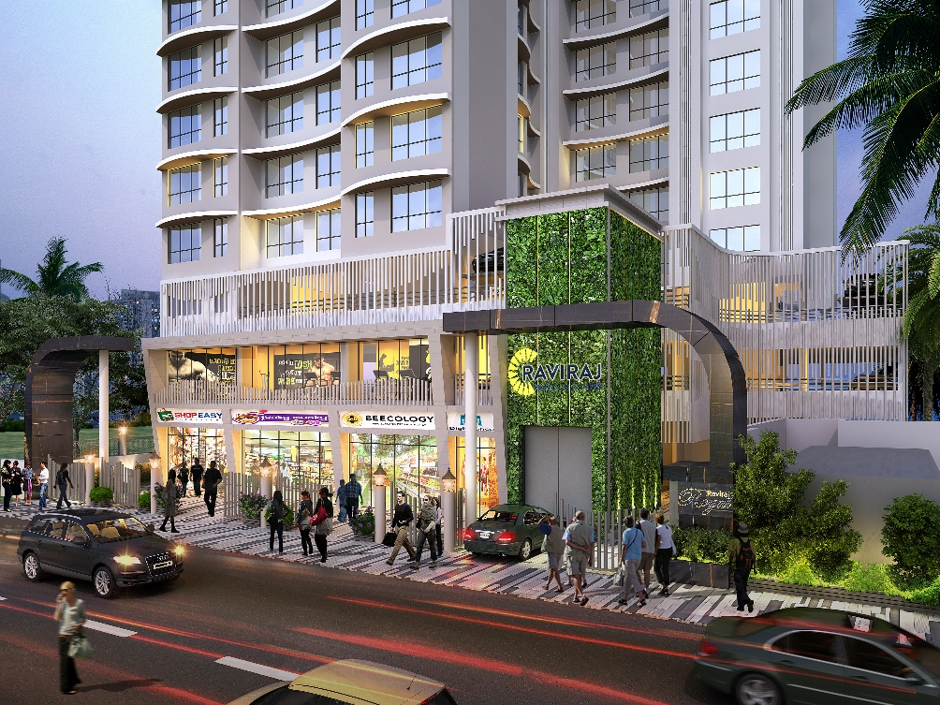
Image 1. Podium.

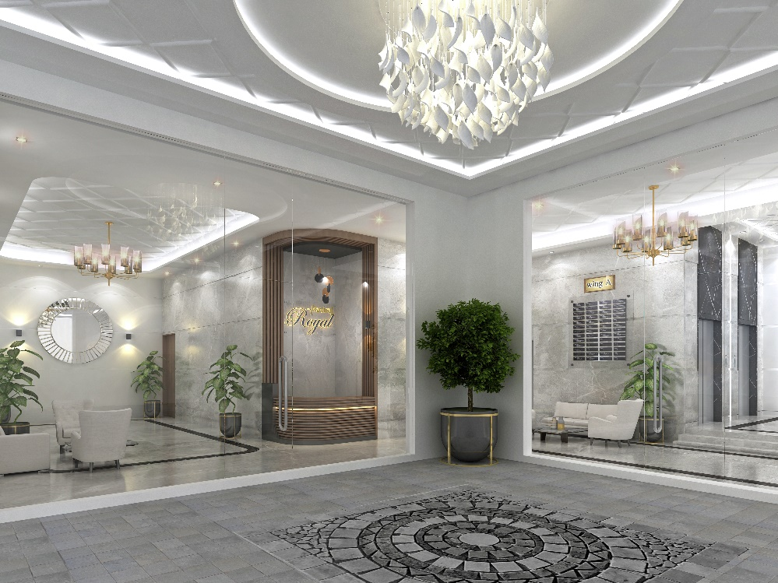
Image 2. Main Lobby.
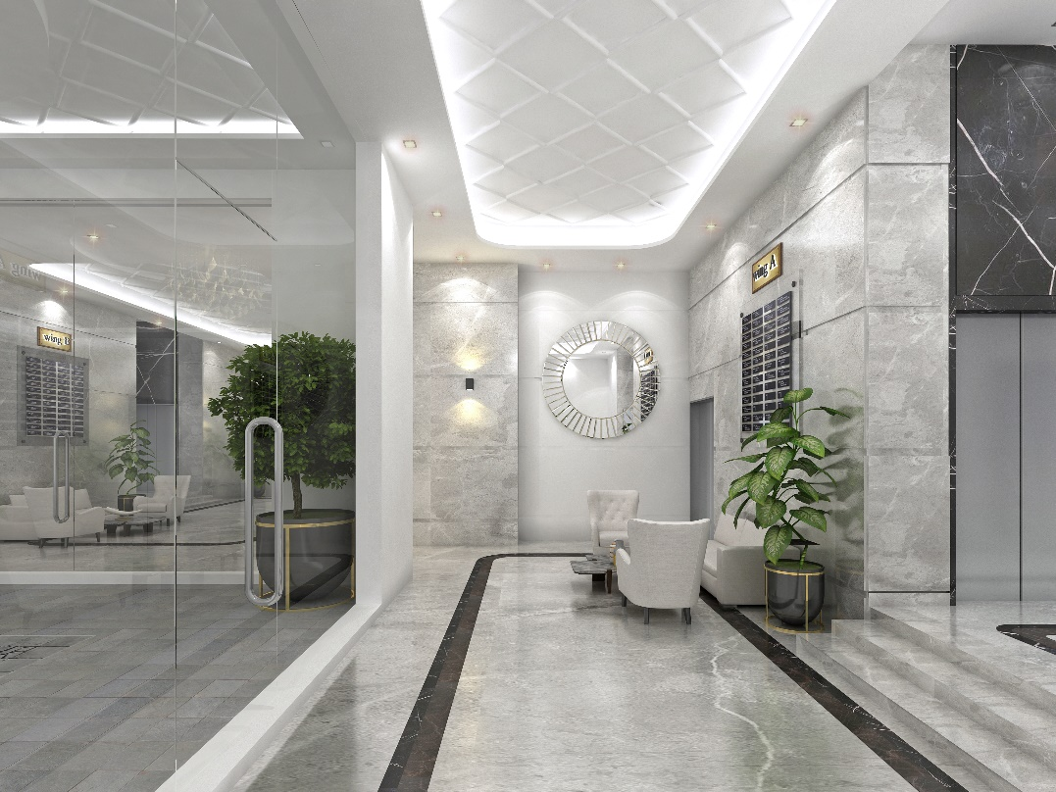
Image 3. Common Lobby.

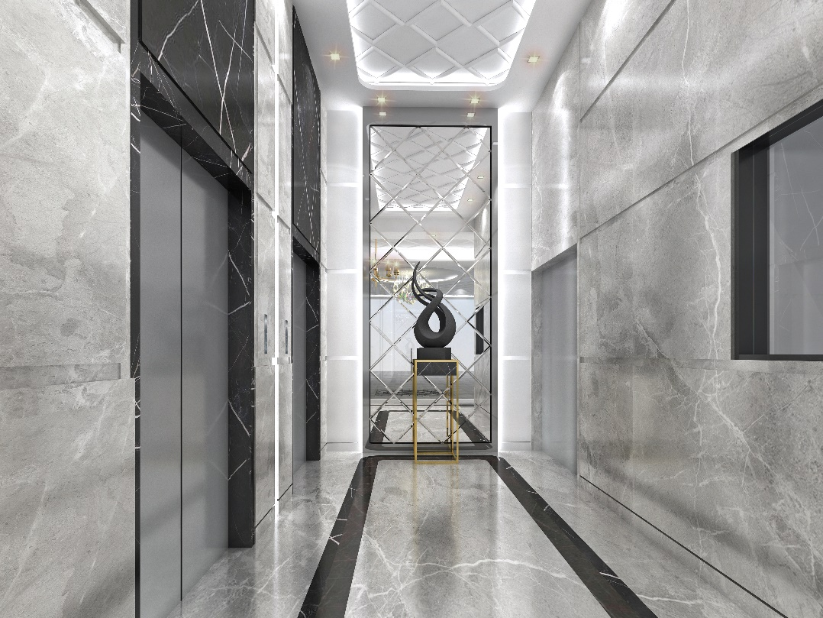
Image 4. Lift Lobby.

